St. Francis Institute of Technology, Mumbai-400 103

**Department Of Information Technology**

A.Y. 2024-2025

Class: TE-ITA/B, Semester: V

Subject: **Advanced DevOps Lab**

**Experiment – 10: To create AWS Lambda function to log “an object has been added” on adding the object to s3 bucket.**

1. **Aim: To author AWS Lambda function from scratch to automatically create and upload non empty json file over s3 bucket and print log “an object has been added” on lambda.** 
2. **Objectives:** Aim of this experiment is that, the students will learn:

* Serverless cloud concept and how to create Lambda function in various languages
* Invoke Lambda function
* Monitoring AWS Lambda

1. **Lab objective mapped : ITL504.6:** To demonstrate a composition of nano services using AWS Lambda and Create Functions with the Serverless Framework.
2. **Prerequisite:** Knowledge of Python/Java/Node.js , AWS console.
3. **Requirements:** AWS account, browser,Personal Computer, Windows operating system, Internet Connection, Google Doc.
4. **Pre-Experiment Exercise:**

Answer the following (write in hand)

1. Explain Serverless concept?
2. Discuss one application of AWS Lambda in your word?

Sample application -Consider a mobile gaming app that writes to a GamesScores table. Whenever the top score of the GameScores table is updated, a corresponding stream record is written to the table’s stream. This event could then trigger a Lambda function that posts a Congratulatory message on a Social media network handle.

**--------------------------------------------------------------------------------------------------------------------------------------------------------------------------------------------------------------------------------------------------------------------------------------------------------------------------------------------------------------------**--------------------------------------------------------------------------------------------------------------------------------------------------------------------------------------------------------------------------------------------------------------------------------------------------------------------------------------------------------------------------------------

**Brief Theory:**

AWS Lambda is a zero-administration compute platform for back-end web developers that

runs your code for you on the AWS Cloud and provides you with a fine-grained pricing

structure. AWS Lambda runs your back-end code on its own AWS compute fleet of Amazon

EC2 instances across multiple Availability Zones in a region, which provides the high

availability, security, performance, and scalability of the AWS infrastructure.

1. **Laboratory Exercise**
   * + 1. **Procedure:**

**a**. **Perfoprm following steps** (attach screenshots)

* Create Execution role using IAM
* policies attached to the created role
* empty s3 bucket
* create Lambda function from console
* create new event for lambda function
* lambda function script
* Invoke Lambda function and verify results
* AWS Lambda automatically monitors Lambda functions and reports metrics
* Clean up resources

1. **Post-Experiments Exercise**
2. **Extended Theory:**(attach SS)

Create the Lambda function using Node.js

1. **Questions:**(write in hand)

* Select which is use case of lambda ?

Image processing web application both Neither 1st and 2nd

* + Lambdas can be created _.

From scratch From the app repository Using a blueprint All of these

* + You want to build and deploy code functions in the AWS Cloud, but do not want to manage the infrastructure. Which of the following services can help meet this requirement?

AWS EC2 AWS API Gateway AWS Lambda AWS DynamoDB

* + What are your thoughts on the concept of auto-scaling in AWS lambda (draw diagram to support your answer)
  + You are using lambda (with large ram allocations) to process videos uploaded to S3 and to convert from their video format to H264. However the operation fails when dealing with particularly large video files. What is the cause of this?

The default 5 minute time out Lambda does not allow video encoding

S3 transfer bottlenecks  S3 cannot talk to Lambda

* + SFIT wants to build an ERP application on the AWS Cloud. SFIT want to ensure that this ERP application follows the Microservices architecture. Which of the following services can be thought of to build this sort of architecture? Choose 3 correct answers

AWS Lambda AWS ECS AWS API Gateway AWS Config

1. **Conclusion:**(write in hand)

1. Write what was performed in the experiment

2. Mention few applications of what was studied.

3. Write the significance of the studied topic

1. **References:**
2. [https://aws.amazon.com/getting-started/hands-on](https://aws.amazon.com/getting-started/hands-on/run-serverless-code/)
3. <https://www.interviewbit.com/aws-lambda-interview-questions/>
4. https://acloudxpert.com/lambda-quiz/9/#answer

**—-------------------------------—---------**

**7. Laboratory Exercise**

**a**. **Perform following steps** (attach screenshots)

* Create Execution role using IAM

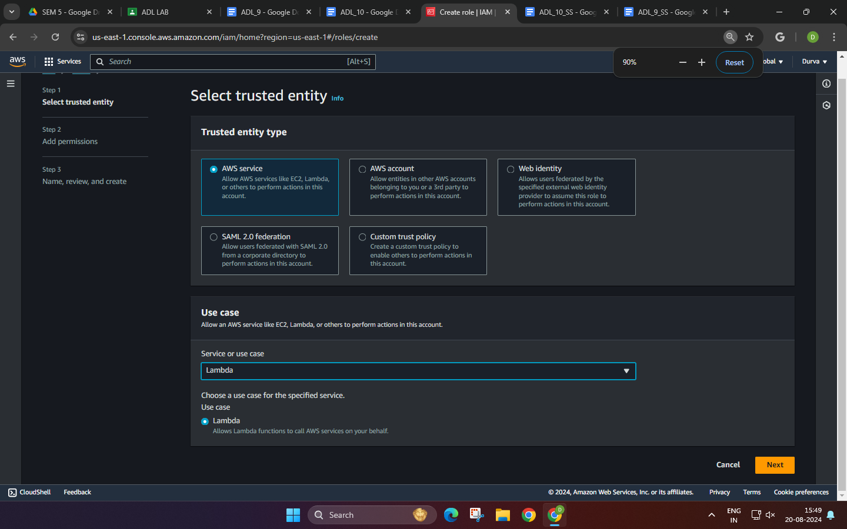

* Policies attached to the created role

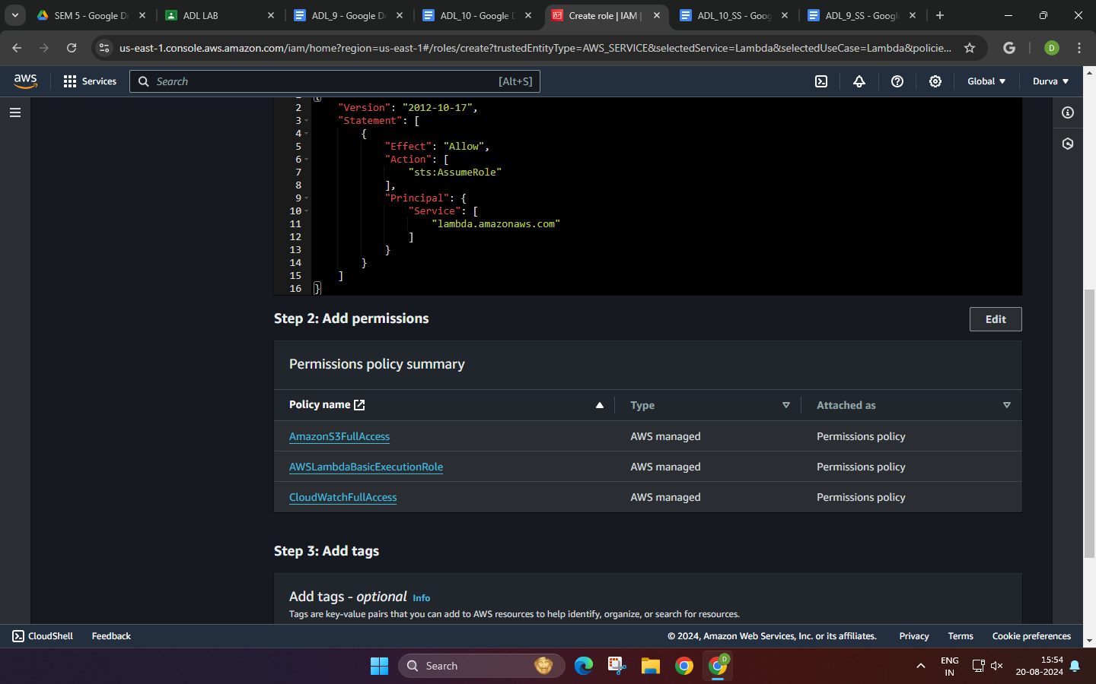

* empty s3 bucket

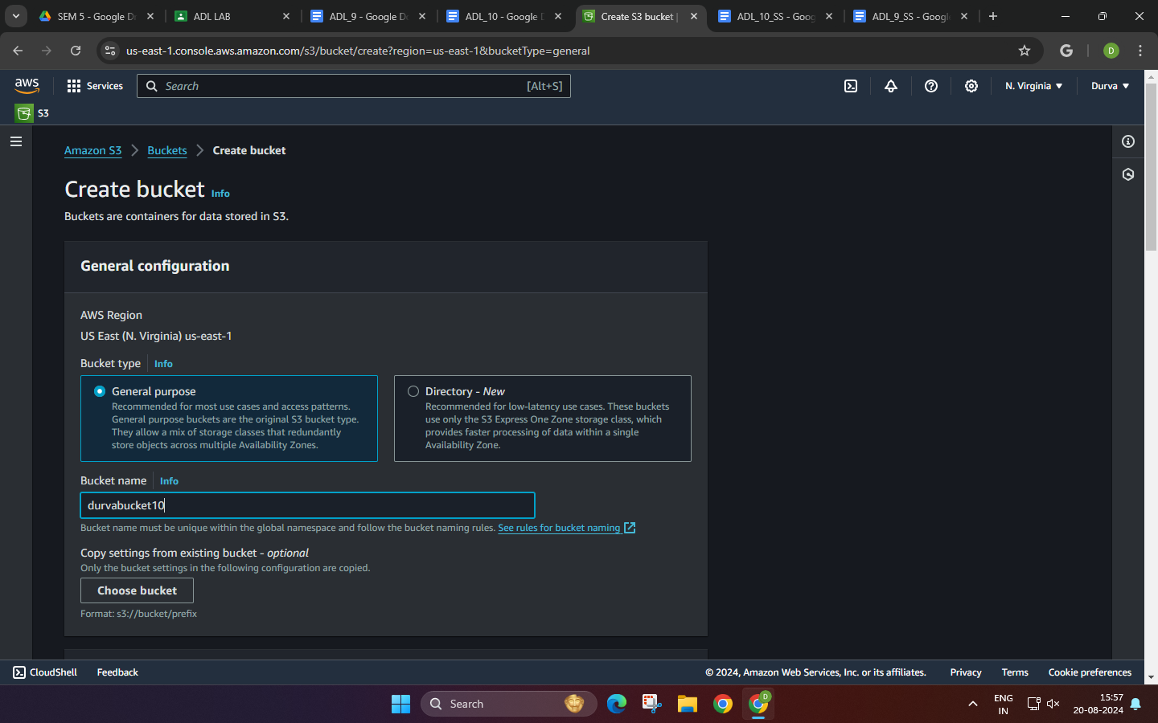

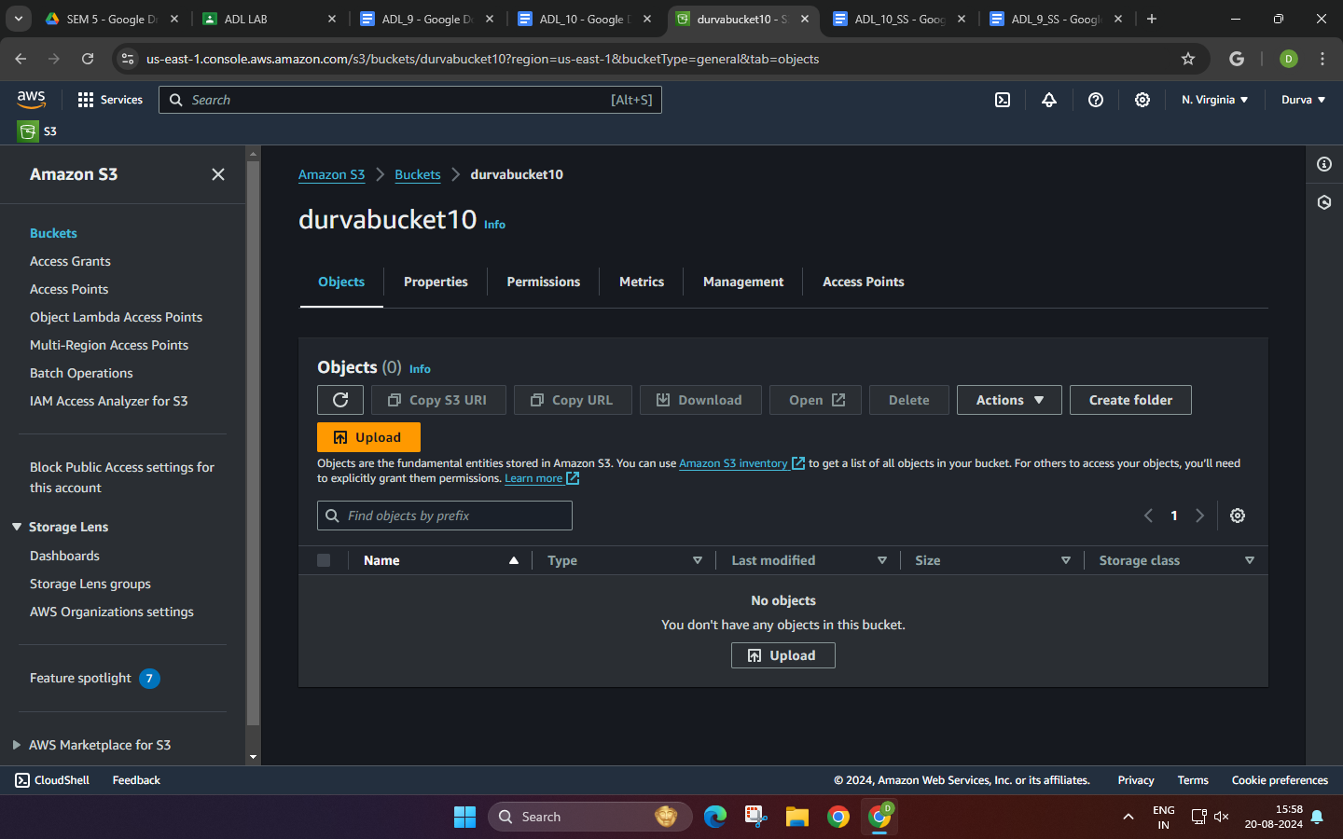

* create Lambda function from console

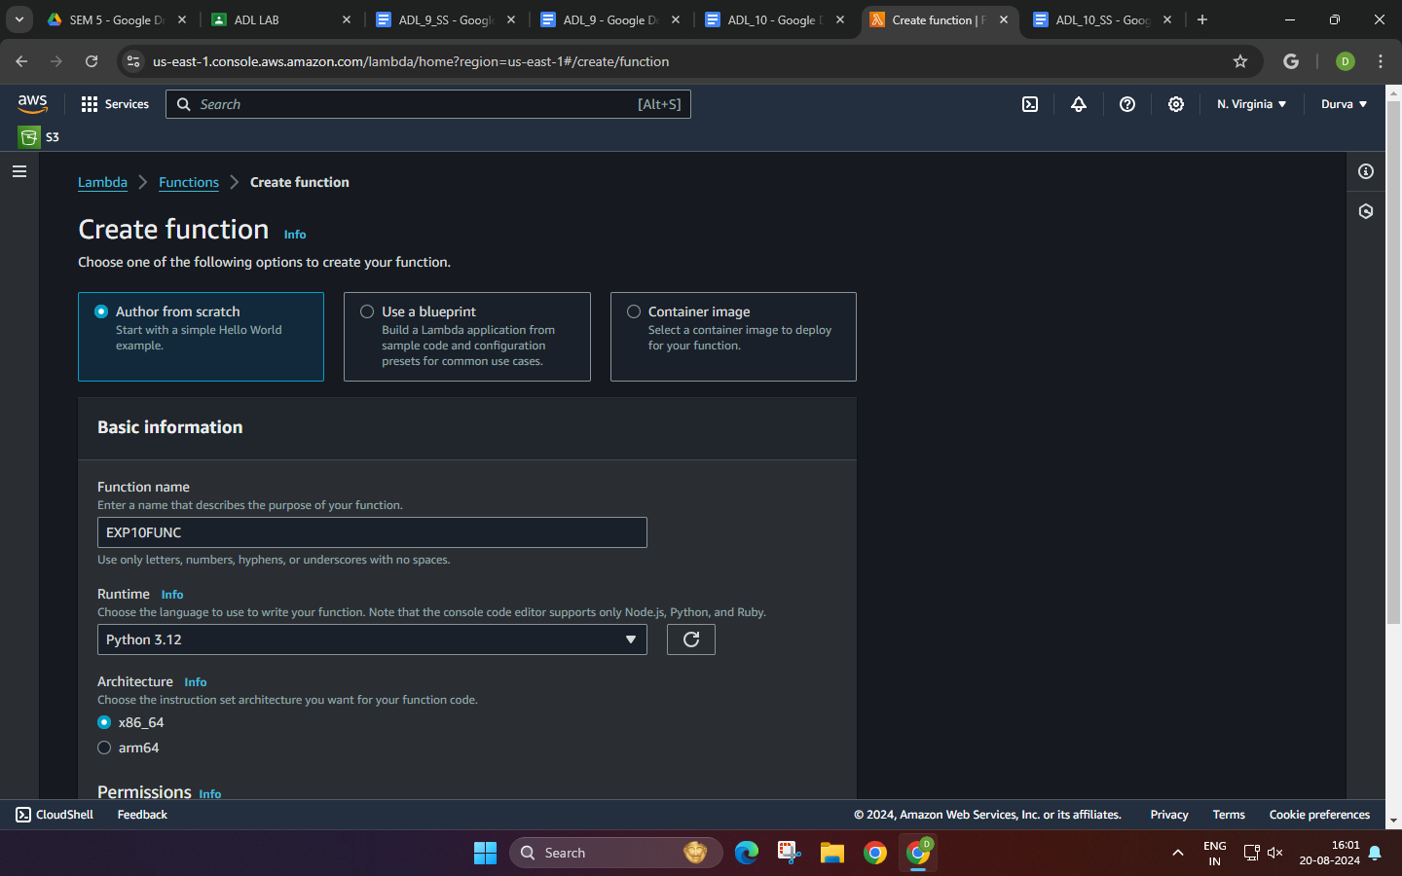

* create new event for lambda function

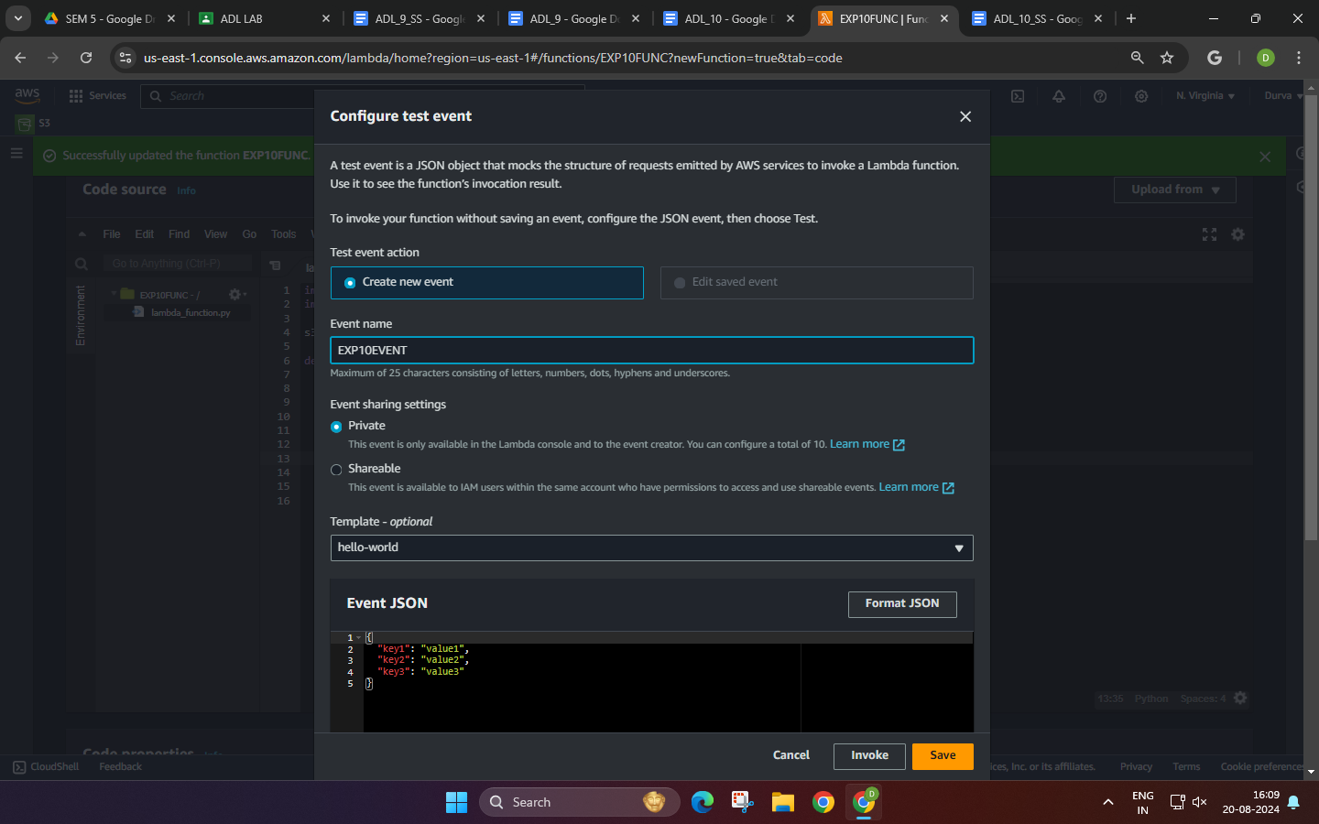

* lambda function script

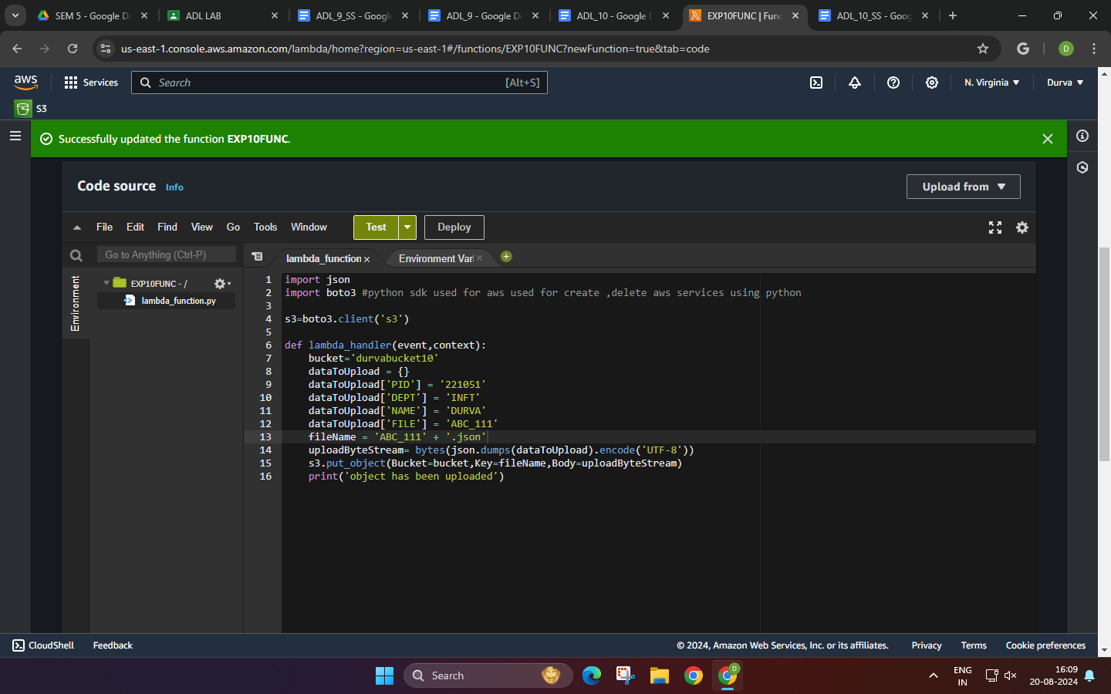

* Invoke Lambda function and verify results

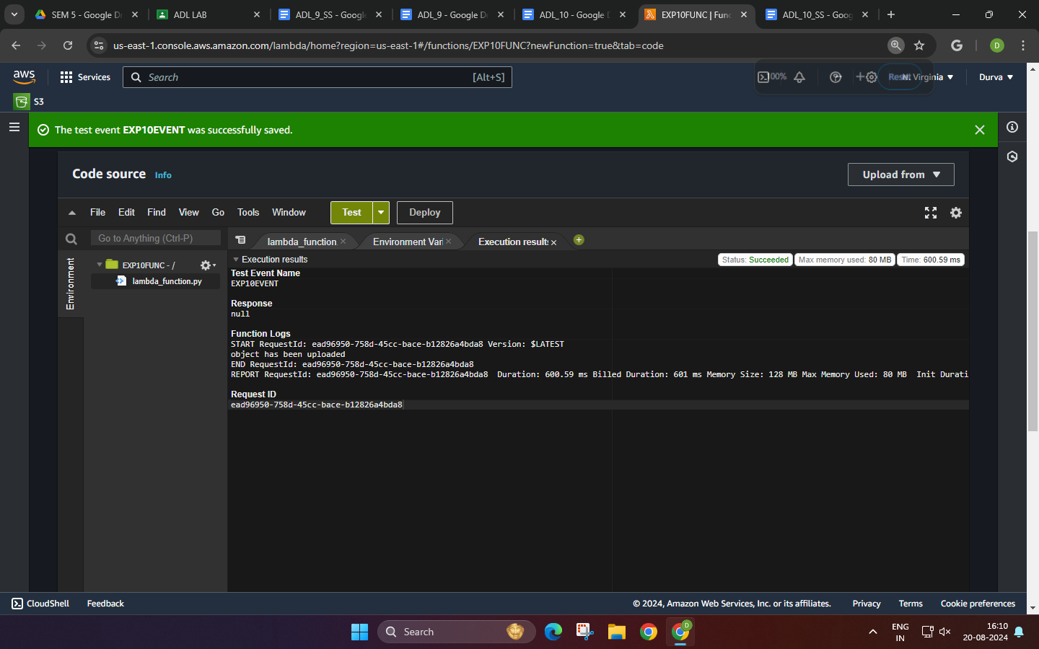

* AWS Lambda automatically monitors Lambda functions and reports metrics

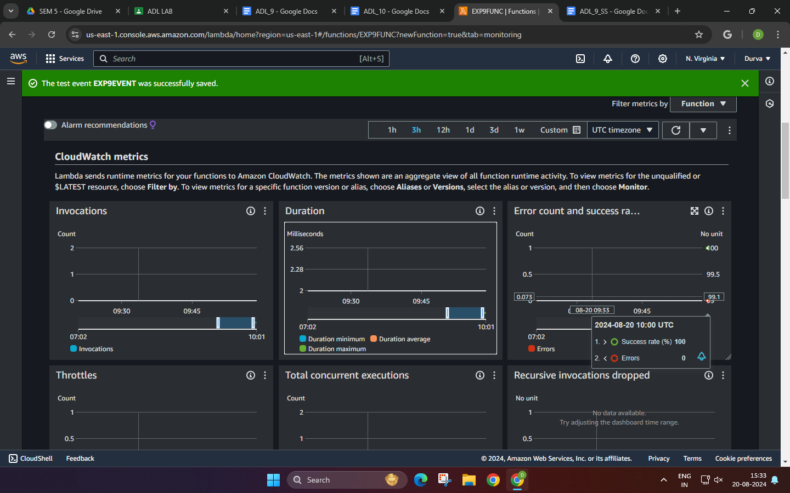

* Clean up resources

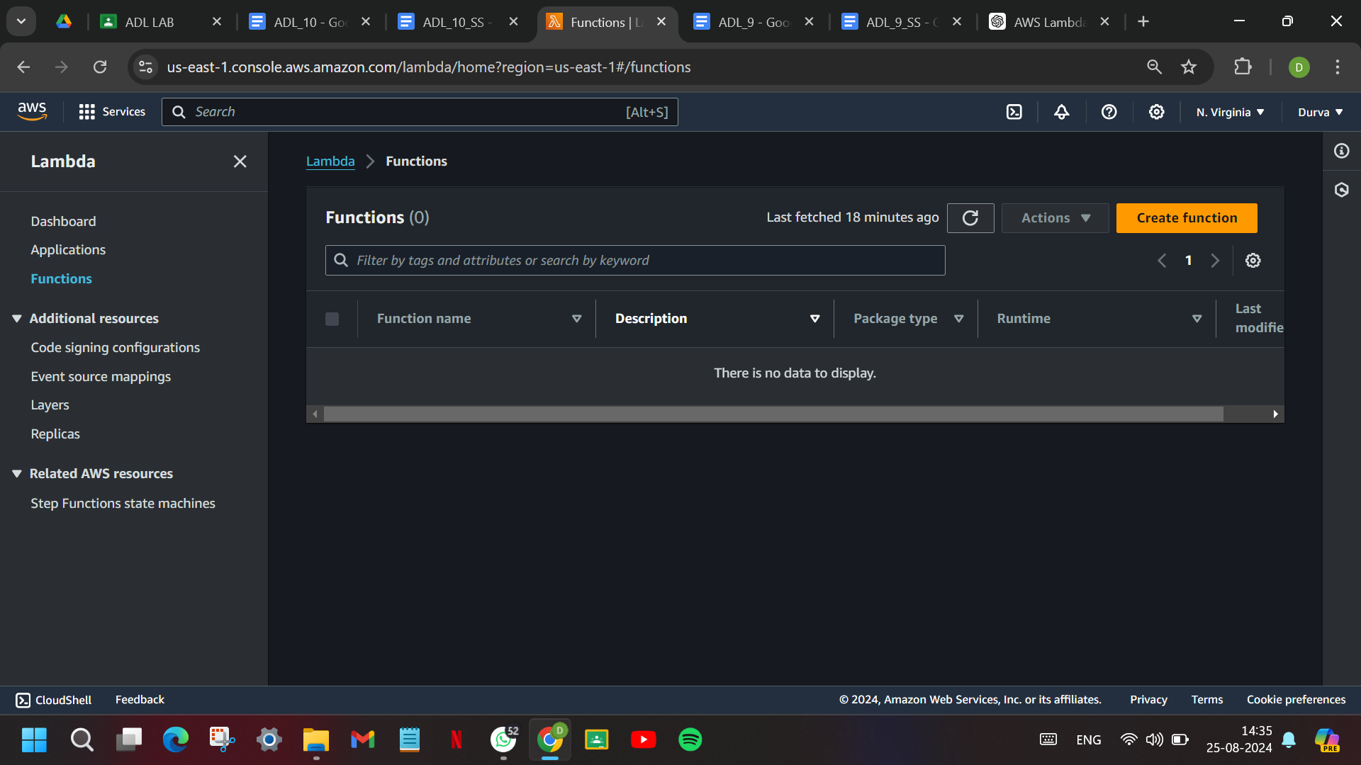

**8. Post-Experiments Exercise**

1. **Extended Theory:** (attach SS)

Create the Lambda function using Node.js

